AI Integration for Sluice CLI Tools
Honestly, it's a brilliant idea and the natural evolution of what you're building. Here's why I think it works so well:
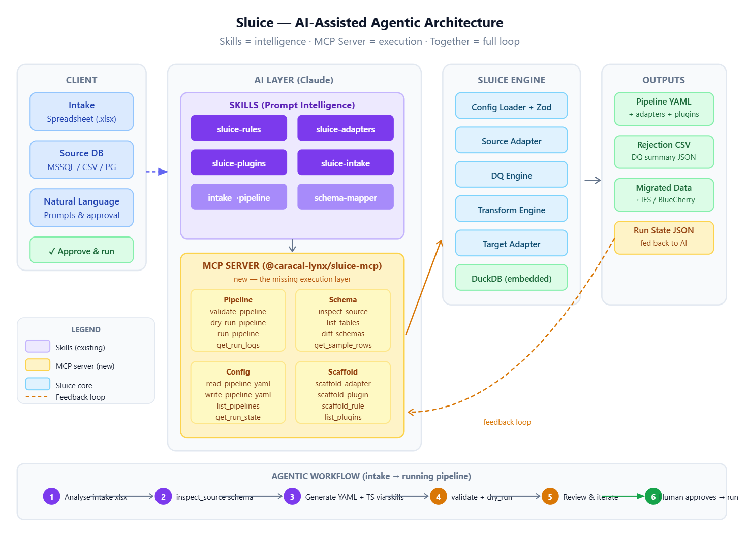
Skills vs MCP — they're complementary, not alternatives. Skills give the AI intelligence — knowing how to structure a Sluice pipeline, what DQ rules make sense for ERP data, how to map source schemas to target adapters. The MCP server gives the AI hands — the ability to actually execute, inspect, validate, and iterate. Together you get an assistant that doesn't just tell the client what to do, but actually does it with them, with human approval before the live run.
What the MCP server unlocks that skills alone can't:
The biggest gap right now is that AI can generate a pipeline YAML but has no way to know if it's actually correct against the live source DB. With inspect_source and get_sample_rows as MCP tools, the AI can see what's actually in the MSSQL instance before generating a single rule — that's a massive quality jump. Similarly, dry_run_pipeline means the AI can validate its own output, read the rejection CSV, and self-correct before the human ever sees it.
The feedback loop is the secret weapon. As shown in the diagram, get_run_state + get_run_logs fed back into the AI creates a proper iterate-until-clean loop: generate → dry run → inspect rejections → fix rules → repeat — all AI-driven, with the client only reviewing the final proposed pipeline.
Implementation notes worth thinking about:
The MCP server would be a thin wrapper (@caracal-lynx/sluice-mcp) that shells out to the existing sluice CLI or calls the engine directly via its TypeScript API. Most of the work is already done in Phase 1. The four tool groups — Pipeline, Schema, Config, and Scaffold — map cleanly onto what the engine already does. The Scaffold tools would just be file system operations that write skeleton files from templates.
Safety-wise, I'd make run_pipeline require an explicit dryRun: false parameter (default true) so there's no accidental data writes in an agentic session.
Packaging: It fits naturally as a Claude Code plugin — a sluice.plugin bundle that includes the MCP server + all the skills. One install and a client's Claude instance becomes a full Sluice collaborator. That's a genuinely marketable offering, not just a developer convenience.
The one thing I'd flag: inspect_source needs read credentials for the client's MSSQL/PG. Worth thinking about how those flow through the MCP context safely — probably via environment variables already in the pipeline YAML, which the MCP server can read.
Shall I sketch out the @caracal-lynx/sluice-mcp package structure and the tool schemas?

